RTL TO GDSII FLOW of SYNCHRONOUS FIFO

RTL Design :
module RTL #(parameter depth = 8 , width = 8 ) (input clk ,rst , wr_en , rd_en , input [width -1 :0] datain , output reg [width -1:0] dataout , output full , empty);

//internal signals
reg [$clog2(depth) - 1:0] wr_ptr , rd_ptr;

//fifo memory
reg [width - 1:0] fifo[0:depth-1] ;

always @(posedge clk) begin
if(rst) begin //synchronous reset
wr_ptr <= 0;
rd_ptr <= 0;
dataout <= 0;
// full <= 0;
//empty <= 0;
end else begin

if(!full & wr_en) begin
fifo[wr_ptr] <= datain;
wr_ptr <= wr_ptr +1 ;
end
if(!empty & rd_en) begin
dataout <= fifo[rd_ptr];
rd_ptr <= rd_ptr +1;
end
end
end
assign empty =(wr_ptr == rd_ptr);
assign full = (wr_ptr + 1 == rd_ptr);
endmodule
Synthesis :
Gate Level Netlist file – fifoRTL.v
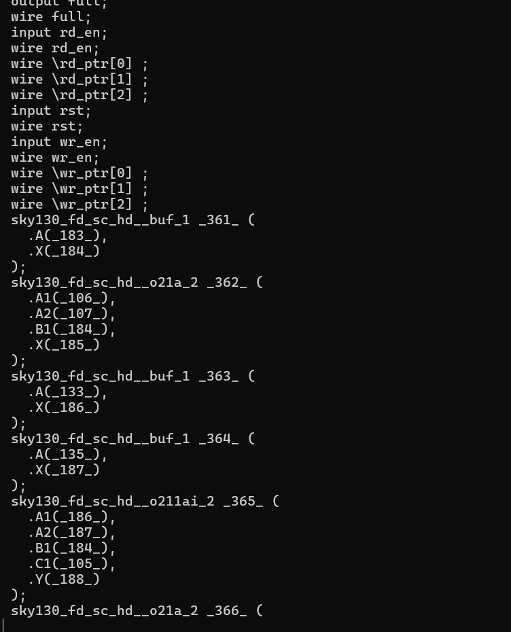

Reports generated by Yosys:

=== fifoRTL ===
Number of wires: 310
Number of wire bits: 324
Number of public wires: 78
Number of public wire bits: 92
Number of memories: 0
Number of memory bits: 0
Number of processes: 0
Number of cells: 312
sky130_fd_sc_hd__a2111oi_2 1
sky130_fd_sc_hd__a211o_2 1
sky130_fd_sc_hd__a21oi_2 5
sky130_fd_sc_hd__a31o_2 2
sky130_fd_sc_hd__a41o_2 1
sky130_fd_sc_hd__and2_2 1
sky130_fd_sc_hd__and2b_2 8
sky130_fd_sc_hd__and3_2 1
sky130_fd_sc_hd__and3b_2 1
sky130_fd_sc_hd__and4_2 1
sky130_fd_sc_hd__and4bb_2 2
sky130_fd_sc_hd__buf_1 87
sky130_fd_sc_hd__dfxtp_2 78
sky130_fd_sc_hd__inv_2 4
sky130_fd_sc_hd__mux2_2 80
sky130_fd_sc_hd__mux4_2 16
sky130_fd_sc_hd__nand2_2 1
sky130_fd_sc_hd__nand3b_2 2
sky130_fd_sc_hd__nor2_2 4
sky130_fd_sc_hd__nor3_2 2
sky130_fd_sc_hd__nor4_2 1
sky130_fd_sc_hd__o21a_2 4
sky130_fd_sc_hd__or2b_2 2
sky130_fd_sc_hd__or4b_2 3
sky130_fd_sc_hd__xnor2_2 2
sky130_fd_sc_hd__xor2_2 2
Chip area for module '\fifoRTL': 3723.571200

53. Printing statistics.

=== fifoRTL ===

Number of wires: 202
Number of wire bits: 300
Number of public wires: 18
Number of public wire bits: 92
Number of memories: 0
Number of memory bits: 0
Number of processes: 0
Number of cells: 273
$_ANDNOT_ 16
$_AND_ 2
$_MUX_ 148
$_NAND_ 2
$_NOT_ 6
$_ORNOT_ 2
$_OR_ 9
$_XNOR_ 2
$_XOR_ 8
sky130_fd_sc_hd__dfxtp_2 78

1-synthesis_dff.stat (END)

Power Estimation Report :
Prerna@LAPTOP-929QFRHD:~/OpenLane/designs/sync_fifo/runs/RUN_2026.04.16_08.24.17/reports/synthesis$ less 2-syn_sta.power.rpt

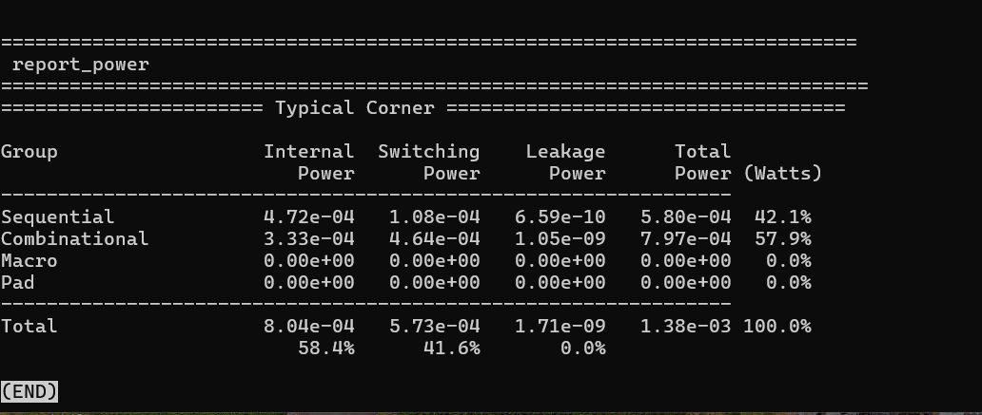

STA Report Summery:
prerna@LAPTOP-929QFRHD:~/OpenLane/designs/sync_fifo/runs/RUN_2026.04.16_08.24.17/reports/synthesis$ less 2-syn_sta.summary.rpt
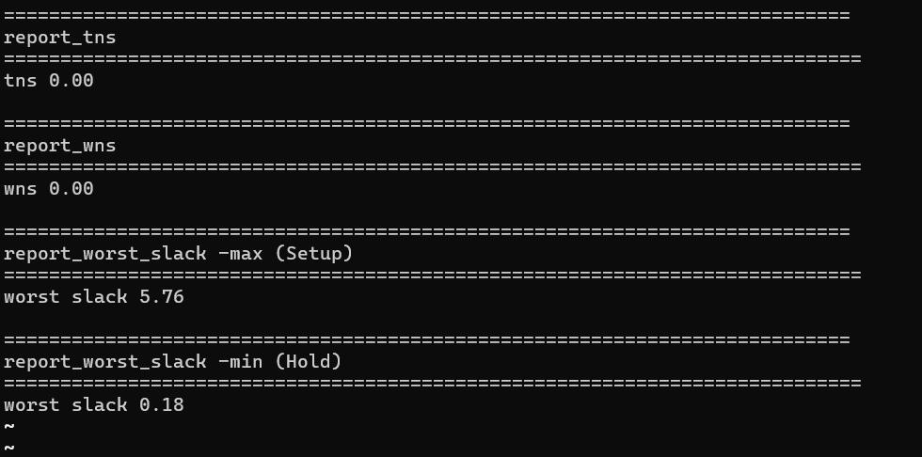
Hold Slack and Setup Slack both are positive meaning timing constraint are met.

Execute these commands in Linux to View Synthesis log
Try: sudo apt install <deb name>
prerna@LAPTOP-929QFRHD:~/OpenLane/designs/sync_fifo$ cd runs
prerna@LAPTOP-929QFRHD:~/OpenLane/designs/sync_fifo/runs$ ls
RUN_2026.04.13_06.40.24 RUN_2026.04.14_08.40.00 RUN_2026.04.14_08.49.14 RUN_2026.04.15_08.00.13 RUN_2026.04.15_08.07.42 RUN_2026.04.15_08.33.45
prerna@LAPTOP-929QFRHD:~/OpenLane/designs/sync_fifo/runs$ cd RUN_2026.04.13_06.40.24
prerna@LAPTOP-929QFRHD:~/OpenLane/designs/sync_fifo/runs/RUN_2026.04.13_06.40.24$ cd logs
prerna@LAPTOP-929QFRHD:~/OpenLane/designs/sync_fifo/runs/RUN_2026.04.13_06.40.24/logs$ cd synthesis
prerna@LAPTOP-929QFRHD:~/OpenLane/designs/sync_fifo/runs/RUN_2026.04.13_06.40.24/logs/synthesis$
prerna@LAPTOP-929QFRHD:~/OpenLane/designs/sync_fifo/runs/RUN_2026.04.13_06.40.24/logs/synthesis$ ls -1
1-synthesis.errors
1-synthesis.log
1-synthesis.warnings
2-sta.errors
2-sta.log
2-sta.warnings
linter.log
prerna@LAPTOP-929QFRHD:~/OpenLane/designs/sync_fifo/runs/RUN_2026.04.13_06.40.24/logs/synthesis$ less 1-synthesis.errors
prerna@LAPTOP-929QFRHD:~/OpenLane/designs/sync_fifo/runs/RUN_2026.04.13_06.40.24/logs/synthesis$ less 1-synthesis.log
prerna@LAPTOP-929QFRHD:~/OpenLane/designs/sync_fifo/runs/RUN_2026.04.13_06.40.24/logs/synthesis$ less 1-synthesis.warnings
prerna@LAPTOP-929QFRHD:~/OpenLane/designs/sync_fifo/runs/RUN_2026.04.13_06.40.24/logs/synthesis$ less 2-sta.errors
prerna@LAPTOP-929QFRHD:~/OpenLane/designs/sync_fifo/runs/RUN_2026.04.13_06.40.24/logs/synthesis$ less 2-sta.warnings
prerna@LAPTOP-929QFRHD:~/OpenLane/designs/sync_fifo/runs/RUN_2026.04.13_06.40.24/logs/synthesis$ less linter.log
prerna@LAPTOP-929QFRHD:~/OpenLane/designs/sync_fifo/runs/RUN_2026.04.13_06.40.24/logs/synthesis$

Results , Warnings , Errors got from all these files
less 1-synthesis.errors -> ABC: Error: The network is combinational.
less 1-synthesis.log -> Yosys report

Chip area for module '\fifoRTL': 3723.571200

62. Executing Verilog backend.
Dumping module `\fifoRTL'.

Warnings: 10 unique messages, 10 total less 1-synthesis.warnings ->

ABC: Warning: Detected 2 multi-output gates (for example, "sky130_fd_sc_hd__fa_1").
Warning: Wire fifoRTL.\full is used but has no driver.
Warning: Wire fifoRTL.\empty is used but has no driver.
Warning: Wire fifoRTL.\dataout [7] is used but has no driver.
Warning: Wire fifoRTL.\dataout [6] is used but has no driver.
Warning: Wire fifoRTL.\dataout [5] is used but has no driver.
Warning: Wire fifoRTL.\dataout [4] is used but has no driver.
Warning: Wire fifoRTL.\dataout [3] is used but has no driver.
Warning: Wire fifoRTL.\dataout [2] is used but has no driver.
Warning: Wire fifoRTL.\dataout [1] is used but has no driver.
Warning: Wire fifoRTL.\dataout [0] is used but has no driver.
Warnings: 10 unique messages, 10 total

less 2-sta.errors-> Blank page appear less 2-sta.warnings -> [WARNING] Did not save OpenROAD database!
~

FLOORPLAN
To view Logs file:
prerna@LAPTOP-929QFRHD:~$
prerna@LAPTOP-929QFRHD:~$ cd ~/OpenLane
prerna@LAPTOP-929QFRHD:~/OpenLane$ cd designs
prerna@LAPTOP-929QFRHD:~/OpenLane/designs$ cd sync_fifo
prerna@LAPTOP-929QFRHD:~/OpenLane/designs/sync_fifo$ cd runs
prerna@LAPTOP-929QFRHD:~/OpenLane/designs/sync_fifo/runs$ ls
RUN_2026.04.13_06.40.24 RUN_2026.04.14_08.49.14 RUN_2026.04.15_08.07.42 RUN_2026.04.15_09.34.41 RUN_2026.04.16_08.24.17
RUN_2026.04.14_08.40.00 RUN_2026.04.15_08.00.13 RUN_2026.04.15_08.33.45 RUN_2026.04.15_09.46.15
prerna@LAPTOP-929QFRHD:~/OpenLane/designs/sync_fifo/runs$ cd RUN_2026.04.16_08.24.17
prerna@LAPTOP-929QFRHD:~/OpenLane/designs/sync_fifo/runs/RUN_2026.04.16_08.24.17$ cd logs
prerna@LAPTOP-929QFRHD:~/OpenLane/designs/sync_fifo/runs/RUN_2026.04.16_08.24.17/logs$ ls
cts floorplan placement routing signoff synthesis
prerna@LAPTOP-929QFRHD:~/OpenLane/designs/sync_fifo/runs/RUN_2026.04.16_08.24.17/logs$ cd floorplan
prerna@LAPTOP-929QFRHD:~/OpenLane/designs/sync_fifo/runs/RUN_2026.04.16_08.24.17/logs/floorplan$ ls
3-initial_fp.errors 3-initial_fp.warnings 4-io.log 5-tap.errors 5-tap.warnings 6-pdn.log
3-initial_fp.log 4-io.errors 4-io.warnings 5-tap.log 6-pdn.errors 6-pdn.warnings
prerna@LAPTOP-929QFRHD:~/OpenLane/designs/sync_fifo/runs/RUN_2026.04.16_08.24.17/logs/floorplan$ less-pdn.log
Using 1e-06 for distance...
Reading design constraints file at '/openlane/designs/sync_fifo/runs/RUN_2026.04.16_08.24.17/tmp/floorplan/3-initial_fp.sdc'…
[INFO PDN-0001] Inserting grid: stdcell_grid
[WARNING PSM-0016] Voltage pad location (VSRC) file not specified, defaulting pad location to checkerboard pattern on core area.
[WARNING PSM-0017] X direction bump pitch is not specified, defaulting to 140um.
[WARNING PSM-0018] Y direction bump pitch is not specified, defaulting to 140um.
[WARNING PSM-0019] Voltage on net VPWR is not explicitly set.
[WARNING PSM-0022] Using voltage 1.800V for VDD network.
[WARNING PSM-0063] Specified bump pitches of 140.000 and 140.000 are less than core width of 108.560 or core height of 106.080. Changing bump location to the center of the die at (59.800, 63.920).
[WARNING PSM-0065] VSRC location not specified, using default checkerboard pattern with one VDD every size bumps in x-direction and one in two bumps in the y-direction
[INFO PSM-0076] Setting metal node density to be standard cell height times 5.
[WARNING PSM-0030] VSRC location at (59.800um, 63.920um) and size 10.000um, is not located on an existing power stripe node. Moving to closest node at (73.370um, 77.180um).
[INFO PSM-0031] Number of PDN nodes on net VPWR = 788.
[INFO PSM-0064] Number of voltage sources = 1.
[INFO PSM-0040] All PDN stripes on net VPWR are connected.
[WARNING PSM-0016] Voltage pad location (VSRC) file not specified, defaulting pad location to checkerboard pattern on core area.
[WARNING PSM-0017] X direction bump pitch is not specified, defaulting to 140um.
[WARNING PSM-0018] Y direction bump pitch is not specified, defaulting to 140um.
[WARNING PSM-0019] Voltage on net VGND is not explicitly set.
[WARNING PSM-0021] Using voltage 0.000V for ground network.
[WARNING PSM-0063] Specified bump pitches of 140.000 and 140.000 are less than core width of 108.560 or core height of 106.080. Changing bump location to the center of the die at (59.800, 63.920).
[WARNING PSM-0065] VSRC location not specified, using default checkerboard pattern with one VDD every size bumps in x-direction and one in two bumps in the y-direction
[INFO PSM-0076] Setting metal node density to be standard cell height times 5.
To View Results by floorplan
prerna@LAPTOP-929QFRHD:~/OpenLane/designs/sync_fifo/runs/RUN_2026.04.16_08.24.17/results$ cd floorplan
prerna@LAPTOP-929QFRHD:~/OpenLane/designs/sync_fifo/runs/RUN_2026.04.16_08.24.17/results/floorplan$ ls
fifoRTL.def fifoRTL.odb
VERSION 5.8 ;
DIVIDERCHAR "/" ;
BUSBITCHARS "[]" ;
DESIGN fifoRTL ;
UNITS DISTANCE MICRONS 1000 ;
DIEAREA ( 0 0 ) ( 119660 130380 ) ;
ROW ROW_0 unithd 5520 10880 N DO 236 BY 1 STEP 460 0 ;
ROW ROW_1 unithd 5520 13600 FS DO 236 BY 1 STEP 460 0 ;
ROW ROW_2 unithd 5520 16320 N DO 236 BY 1 STEP 460 0 ;
ROW ROW_3 unithd 5520 19040 FS DO 236 BY 1 STEP 460 0 ;
ROW ROW_4 unithd 5520 21760 N DO 236 BY 1 STEP 460 0 ;
ROW ROW_5 unithd 5520 24480 FS DO 236 BY 1 STEP 460 0 ;
ROW ROW_6 unithd 5520 27200 N DO 236 BY 1 STEP 460 0 ;
ROW ROW_7 unithd 5520 29920 FS DO 236 BY 1 STEP 460 0 ;
ROW ROW_8 unithd 5520 32640 N DO 236 BY 1 STEP 460 0 ;
ROW ROW_9 unithd 5520 35360 FS DO 236 BY 1 STEP 460 0 ;
ROW ROW_10 unithd 5520 38080 N DO 236 BY 1 STEP 460 0 ;
ROW ROW_11 unithd 5520 40800 FS DO 236 BY 1 STEP 460 0 ;
ROW ROW_12 unithd 5520 43520 N DO 236 BY 1 STEP 460 0 ;
ROW ROW_13 unithd 5520 46240 FS DO 236 BY 1 STEP 460 0 ;
ROW ROW_14 unithd 5520 48960 N DO 236 BY 1 STEP 460 0 ;
ROW ROW_15 unithd 5520 51680 FS DO 236 BY 1 STEP 460 0 ;
ROW ROW_16 unithd 5520 54400 N DO 236 BY 1 STEP 460 0 ;
ROW ROW_17 unithd 5520 57120 FS DO 236 BY 1 STEP 460 0 ;
ROW ROW_18 unithd 5520 59840 N DO 236 BY 1 STEP 460 0 ;
ROW ROW_19 unithd 5520 62560 FS DO 236 BY 1 STEP 460 0 ;
ROW ROW_20 unithd 5520 65280 N DO 236 BY 1 STEP 460 0 ;
ROW ROW_21 unithd 5520 68000 FS DO 236 BY 1 STEP 460 0 ;
ROW ROW_22 unithd 5520 70720 N DO 236 BY 1 STEP 460 0 ;
fifoRTL.def
def file -> DESIGN EXCHANGE FORMAT , includes Die area , cell placement

PLACEMENT:
View Log results of Placement:
7-global.logs
[INFO GPL-0013] DieAreaUxUy: 119660 130380
[INFO GPL-0014] CoreAreaLxLy: 5520 10880
[INFO GPL-0015] CoreAreaUxUy: 114080 116960
[INFO GPL-0016] CoreArea: 11516044800
[INFO GPL-0017] NonPlaceInstsArea: 497977600
[INFO GPL-0018] PlaceInstsArea: 4719526400
[INFO GPL-0019] Util(%): 42.83
[INFO GPL-0020] StdInstsArea: 4719526400
[INFO GPL-0021] MacroInstsArea: 0
[InitialPlace] Iter: 1 CG residual: 0.00000008 HPWL: 6357090
[InitialPlace] Iter: 2 CG residual: 0.00000011 HPWL: 5979365
[InitialPlace] Iter: 3 CG residual: 0.00000011 HPWL: 5997319
[InitialPlace] Iter: 4 CG residual: 0.00000010 HPWL: 6019356
[InitialPlace] Iter: 5 CG residual: 0.00000010 HPWL: 6019809
[INFO GPL-0031] FillerInit: NumGCells: 621
[INFO GPL-0032] FillerInit: NumGNets: 453
[INFO GPL-0033] FillerInit: NumGPins: 1585
[INFO GPL-0023] TargetDensity: 0.60
[INFO GPL-0024] AveragePlaceInstArea: 10701873
[INFO GPL-0025] IdealBinArea: 17836454
[INFO GPL-0026] IdealBinCnt: 645
[INFO GPL-0027] TotalBinArea: 11516044800
[INFO GPL-0028] BinCnt: 16 16
[INFO GPL-0029] BinSize: 6785 6630
[INFO GPL-0030] NumBins: 256
[NesterovSolve] Iter: 1 overflow: 0.917157 HPWL: 3248079
[NesterovSolve] Iter: 10 overflow: 0.822022 HPWL: 4076763
[NesterovSolve] Iter: 20 overflow: 0.824431 HPWL: 4054748
[NesterovSolve] Iter: 30 overflow: 0.824006 HPWL: 4054798
:

Finished with Overflow: 0.098993
42% low utilization of standard cells in core area. Means plenty of spaces which indicates Placement is safe but not area optimized
- Good for Routing
Only standard cells are placed , No macros because Synchronous fifo, a simple design.
Overflow measures cell density violation meaning standard cells are legalized (no overlapping between them)

10-detailed.log
detailed_placement.log, which reflects the legalization + refinement stage after global placement. This is where overlaps are fixed and cells are snapped to legal rows.
Components of this program may be licensed under more restrictive licenses which must be honored.
[INFO]: Reading ODB at '/openlane/designs/sync_fifo/runs/RUN_2026.04.16_08.24.17/tmp/placement/9-resizer.odb'…
define_corners Typical
read_liberty -corner Typical /home/prerna/.ciel/sky130A/libs.ref/sky130_fd_sc_hd/lib/sky130_fd_sc_hd__tt_025C_1v80.lib
Using 1e-12 for capacitance...
Using 1e+03 for resistance...
Using 1e-09 for time...
Using 1e+00 for voltage...
Using 1e-03 for current...
Using 1e-09 for power...
Using 1e-06 for distance...
Reading design constraints file at '/openlane/designs/sync_fifo/runs/RUN_2026.04.16_08.24.17/tmp/placement/9-resizer.sdc'…
Placement Analysis
---------------------------------
total displacement 0.0 u
average displacement 0.0 u
max displacement 0.0 u
original HPWL 9447.8 u
legalized HPWL 9682.6 u
delta HPWL 2 %

[INFO DPL-0020] Mirrored 163 instances
[INFO DPL-0021] HPWL before 9682.6 u
[INFO DPL-0022] HPWL after 9447.8 u
[INFO DPL-0023] HPWL delta -2.4 %
Setting global connections for newly added cells…
10-detailed.log

total displacement 0.0 u
average displacement 0.0 u
max displacement 0.0 u
Interpretation:
  - Global placement already produced legal positions
  - No overlaps required fixing
HPWL increased slightly after legalization (+2%) : it is Normal because legalization enforces row alignment so slight wirelength is expected

Similarly view Results file: fifoRTL.def which contains ROWS , TRACKS , CELL Placement
Reports generated by Placement :
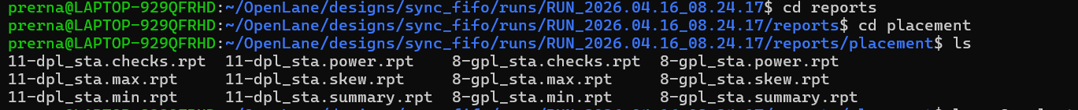

Clock Tree Synthesis
View results generated by CTS :
prerna@LAPTOP-929QFRHD:~/OpenLane/designs/sync_fifo/runs/RUN_2026.04.20_07.24.13/results$ cd cts
prerna@LAPTOP-929QFRHD:~/OpenLane/designs/sync_fifo/runs/RUN_2026.04.20_07.24.13/results/cts$ ls
fifoRTL.def fifoRTL.odb fifoRTL.sdc
less fifoRTL.def
COMPONENTS 713 ;
- PHY_0 sky130_fd_sc_hd__decap_3 + SOURCE DIST + FIXED ( 5520 10880 ) N ;
- PHY_1 sky130_fd_sc_hd__decap_3 + SOURCE DIST + FIXED ( 112700 10880 ) FN ;
- PHY_10 sky130_fd_sc_hd__decap_3 + SOURCE DIST + FIXED ( 5520 24480 ) FS ;
- PHY_11 sky130_fd_sc_hd__decap_3 + SOURCE DIST + FIXED ( 112700 24480 ) S ;
- PHY_12 sky130_fd_sc_hd__decap_3 + SOURCE DIST + FIXED ( 5520 27200 ) N ;
- PHY_13 sky130_fd_sc_hd__decap_3 + SOURCE DIST + FIXED ( 112700 27200 ) FN ;
- PHY_14 sky130_fd_sc_hd__decap_3 + SOURCE DIST + FIXED ( 5520 29920 ) FS ;
- PHY_15 sky130_fd_sc_hd__decap_3 + SOURCE DIST + FIXED ( 112700 29920 ) S ;
- PHY_16 sky130_fd_sc_hd__decap_3 + SOURCE DIST + FIXED ( 5520 32640 ) N ;
- PHY_17 sky130_fd_sc_hd__decap_3 + SOURCE DIST + FIXED ( 112700 32640 ) FN ;
- PHY_18 sky130_fd_sc_hd__decap_3 + SOURCE DIST + FIXED ( 5520 35360 ) FS ;
- PHY_19 sky130_fd_sc_hd__decap_3 + SOURCE DIST + FIXED ( 112700 35360 ) S ;
after CTS process component get increased because of addition of buffers .

View logs file generated by CTS:
prerna@LAPTOP-929QFRHD:~/OpenLane/designs/sync_fifo/runs/RUN_2026.04.20_07.24.13$ cd logs
prerna@LAPTOP-929QFRHD:~/OpenLane/designs/sync_fifo/runs/RUN_2026.04.20_07.24.13/logs$ cd cts
prerna@LAPTOP-929QFRHD:~/OpenLane/designs/sync_fifo/runs/RUN_2026.04.20_07.24.13/logs/cts$ ls
12-cts.errors 12-cts.warnings 13-cts_sta.log 14-resizer.errors 14-resizer.warnings
12-cts.log 13-cts_sta.errors 13-cts_sta.warnings 14-resizer.log
- Check 12-cts.errors- if empty means no error in CTS
- Less 12-cts.log ( main CTS execution)
Reading cts.log

- CTS engine (OpenROAD TritonCTS) chose: sky130_fd_sc_hd__clkbuf_8
This is the clock buffer cell used to build the clock tree.

- Pattern Generation , CTS is building delay model for clock buffer
[INFO CTS-0038] Number of created patterns = 50000.
[INFO CTS-0038] Number of created patterns = 100000.
[INFO CTS-0039] Number of created patterns = 141984. -> more accurate clock delay estimation
[INFO]: Reading ODB at '/openlane/designs/sync_fifo/runs/RUN_2026.04.20_07.24.13/results/placement/fifoRTL.odb'…
define_corners Slowest Typical Fastest
read_liberty -corner Slowest /openlane/designs/sync_fifo/runs/RUN_2026.04.20_07.24.13/tmp/cts/cts-slowest.lib
read_liberty -corner Typical /openlane/designs/sync_fifo/runs/RUN_2026.04.20_07.24.13/tmp/cts/cts.lib
read_liberty -corner Fastest /openlane/designs/sync_fifo/runs/RUN_2026.04.20_07.24.13/tmp/cts/cts-fastest.lib
Using 1e-12 for capacitance...
Using 1e+03 for resistance...
Using 1e-09 for time...
Using 1e+00 for voltage...
Using 1e-03 for current...
Using 1e-09 for power...
Using 1e-06 for distance...
Reading design constraints file at '/openlane/designs/sync_fifo/runs/RUN_2026.04.20_07.24.13/tmp/placement/9-resizer.sdc'…
[INFO]: Setting RC values...
[INFO]: Configuring cts characterization...
[INFO]: Performing clock tree synthesis...
[INFO]: Looking for the following net(s): clk
[INFO]: Running Clock Tree Synthesis...
[INFO CTS-0049] Characterization buffer is: sky130_fd_sc_hd__clkbuf_8.
[INFO CTS-0038] Number of created patterns = 50000.
[INFO CTS-0038] Number of created patterns = 100000.
[INFO CTS-0039] Number of created patterns = 141984.
[INFO CTS-0084] Compiling LUT.
Min. len Max. len Min. cap Max. cap Min. slew Max. slew
2 8 1 35 1 12 1 12
:
- Generated pattern compiled to LUT (lookup table) characterization range before actual tree construct .
Parameter | Meaning
len (2–8) | Wire length range (routing segments)
cap (1–35) | Load capacitance range
slew (1–12) | Input transition time range ( CTS will interpolate values within this range

[WARNING CTS-0043] 4896 wires are pure wire and no slew degradation. Meaning
These wires are light load and signal transition (slew) does not degrade so they don’t need buffering( skew Modelling)
cts_report
[INFO CTS-0003] Total number of Clock Roots: 1.
[INFO CTS-0004] Total number of Buffers Inserted: 9.
[INFO CTS-0005] Total number of Clock Subnets: 9.
[INFO CTS-0006] Total number of Sinks: 78.
cts_report_end
[WARNING CTS-0043] 4896 wires are pure wire and no slew degradation.
TritonCTS forced slew degradation on these wires.
[INFO CTS-0046] Number of wire segments: 141984.
[INFO CTS-0047] Number of keys in characterization LUT: 1624.
[INFO CTS-0048] Actual min input cap: 1.
[INFO CTS-0007] Net "clk" found for clock "clk".
[INFO CTS-0010] Clock net "clk" has 78 sinks.
[INFO CTS-0008] TritonCTS found 1 clock nets.
[INFO CTS-0097] Characterization used 2 buffer(s) types.
[INFO CTS-0027] Generating H-Tree topology for net clk.
[INFO CTS-0028] Total number of sinks: 78.
[INFO CTS-0029] Sinks will be clustered in groups of up to 25 and with maximum cluster diameter of 50.0 um.
[INFO CTS-0030] Number of static layers: 0.
Clock source = 1 means single source driving to entire fifo
CTS inserted 9 clock buffers which are reasonable for fifo design
Clock tree divided into 9 branches and each subnet driven by Buffer
Sinks are 78 (flip flops/ registers ) driven by clock

reading less 13-cts_sta.log ( Post STA)
both Hold Slack and Setup Slack are positive – all timing constraints are satisfied (NO VIOLATION)

(setup is large because of large clock period)
report_worst_slack -max (Setup) worst slack 5.58 report_worst_slack -min (Hold) worst slack 0.18
(hold is less , sensitive to clock skew)

Meaning Clock tree is well-balanced
- No excessive skew causing hold failures
- Buffer insertion (9 buffers) was sufficient

reading 14-cts.resizer.log (POST resizer stage)
- stage fixes timing violations using buffering, resizing, etc.
Writing timing constraints to '/openlane/designs/sync_fifo/runs/RUN_2026.04.20_07.24.13/tmp/cts/14-fifoRTL.resized.sdc'…
area_report

===========================================================================
report_design_area
============================================================================
Design area 5204 u^2 45% utilization.
area_report_end
this is the Standard cell area after inserting clock buffers into Original fifo Logic
ideal placement utilization – 45% ( cell area/ core area)
- Easier routing
- Lower conjection
- Area under control
- ====================================================
View Reports by CTS
prerna@LAPTOP-929QFRHD:~/OpenLane/designs/sync_fifo/runs/RUN_2026.04.20_07.24.13$ cd reports
prerna@LAPTOP-929QFRHD:~/OpenLane/designs/sync_fifo/runs/RUN_2026.04.20_07.24.13/reports$ cd cts
prerna@LAPTOP-929QFRHD:~/OpenLane/designs/sync_fifo/runs/RUN_2026.04.20_07.24.13/reports/cts$ ls
13-cts_sta.checks.rpt 13-cts_sta.min.rpt 13-cts_sta.skew.rpt
13-cts_sta.max.rpt 13-cts_sta.power.rpt 13-cts_sta.summary.rpt

Reading sta.summary.rpt

===========================================================================
report_tns
============================================================================
tns 0.00

===========================================================================
report_wns
============================================================================
wns 0.00

===========================================================================
report_worst_slack -max (Setup)
============================================================================
worst slack 5.58

===========================================================================
report_worst_slack -min (Hold)
============================================================================
worst slack 0.18

Reading 13-cts.skew.rpt
===========================================================================
report_clock_skew
============================================================================
Clock clk
Latency CRPR Skew
_791_/CLK ^
0.41
_731_/CLK ^
0.36 -0.02 0.02
Latency - Time taken for clock to reach each flip-flop.
Skew – difference in arrival time ( 0.02ns which is extremely small – ideal clock tree)

Routing
View Results
prerna@LAPTOP-929QFRHD:~/OpenLane/designs/sync_fifo/runs/RUN_2026.04.20_07.24.13/results$ cd routing
prerna@LAPTOP-929QFRHD:~/OpenLane/designs/sync_fifo/runs/RUN_2026.04.20_07.24.13/results/routing$ ls
fifoRTL.def fifoRTL.nl.v fifoRTL.odb fifoRTL.pnl.v mca
less fifoRTl.def - you will find antenna and components will increased
less fifoRTl.nl.v – final netlist after routing

View Reports
- DRC check :
Less drt.drc
Blank file appeared , look for violations
Less drt.klayout.xml

<?xml version="1.0" ?>
<report-database>
<categories/>
<cells>
<cell>
<name>fifoRTL </name>
</cell>
</cells>
<items/>
</report-database> ~

- <categories/> → No violation categories exist
- <items/> → No DRC violation instances found

- Timing after Routing (STA)
25-grt_sta.checks.rpt
25-grt_sta.max.rpt
25-grt_sta.min.rpt
25-grt_sta.power.rpt
25-grt_sta.skew.rpt
25-grt_sta.summary.rpt ( view this file to check Hold Slack and setup slack)
View logs
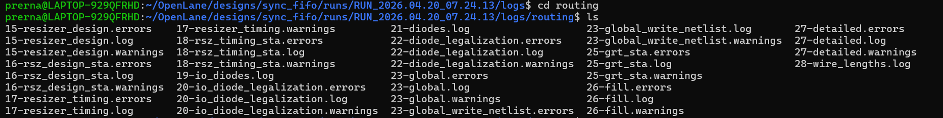
Less 27-detailed.log: look for total violations
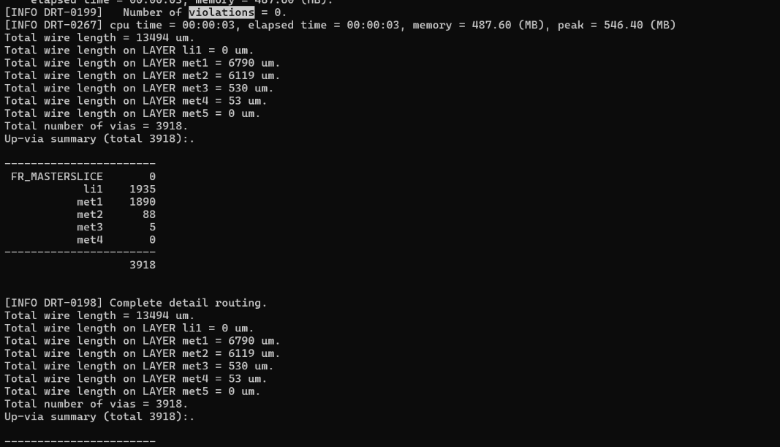
Less 23-global.log
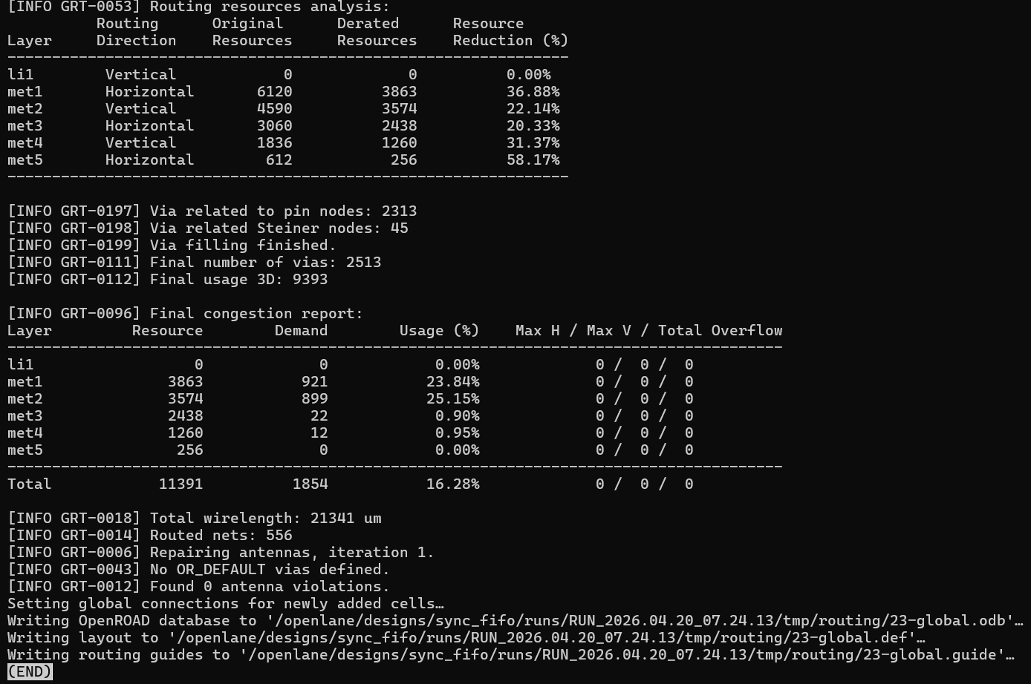
Signoff
View Reports
prerna@LAPTOP-929QFRHD:~/OpenLane/designs/sync_fifo/runs$ cd RUN_2026.04.22_08.11.11
prerna@LAPTOP-929QFRHD:~/OpenLane/designs/sync_fifo/runs/RUN_2026.04.22_08.11.11$ cd reports
prerna@LAPTOP-929QFRHD:~/OpenLane/designs/sync_fifo/runs/RUN_2026.04.22_08.11.11/reports$ cd signoff
prerna@LAPTOP-929QFRHD:~/OpenLane/designs/sync_fifo/runs/RUN_2026.04.22_08.11.11/reports/signoff$ ls
30-mca 35-rcx_sta.min.rpt 36-irdrop-VPWR.rpt 45-antenna_violators_pins.txt drc.tr
32-mca 35-rcx_sta.power.rpt 39-xor.rpt drc.klayout.xml fifoRTL.rpt
34-mca 35-rcx_sta.skew.rpt 39-xor.xml drc.rdb fifoRTL.rpt.debug.gz
35-rcx_sta.checks.rpt 35-rcx_sta.summary.rpt 43-fifoRTL.lvs.rpt drc.rpt fifoRTL.rpt.error.gz
35-rcx_sta.max.rpt 36-irdrop-VGND.rpt 45-antenna_violators.rpt drc.tcl spice.feedback.txt

Open drc.rpt
fifoRTL
----------------------------------------
[INFO]: COUNT: 0
[INFO]: Should be divided by 3 or 4

Count = 0 means NO DRC violations Layout is clean and manufacturable

Should be divided by 3 or 4
This line:
- Is not an error
- Is a known informational message from Magic
- Related to internal rule grouping / tiling

Now check less lvs.rpt
LVS reports no net, device, pin, or property mismatches. Total errors = 0 43-fifoRTL.lvs.rpt (END)
Interpretation
No missing or extra devices
No pin mismatches
No parameter/property mismatches
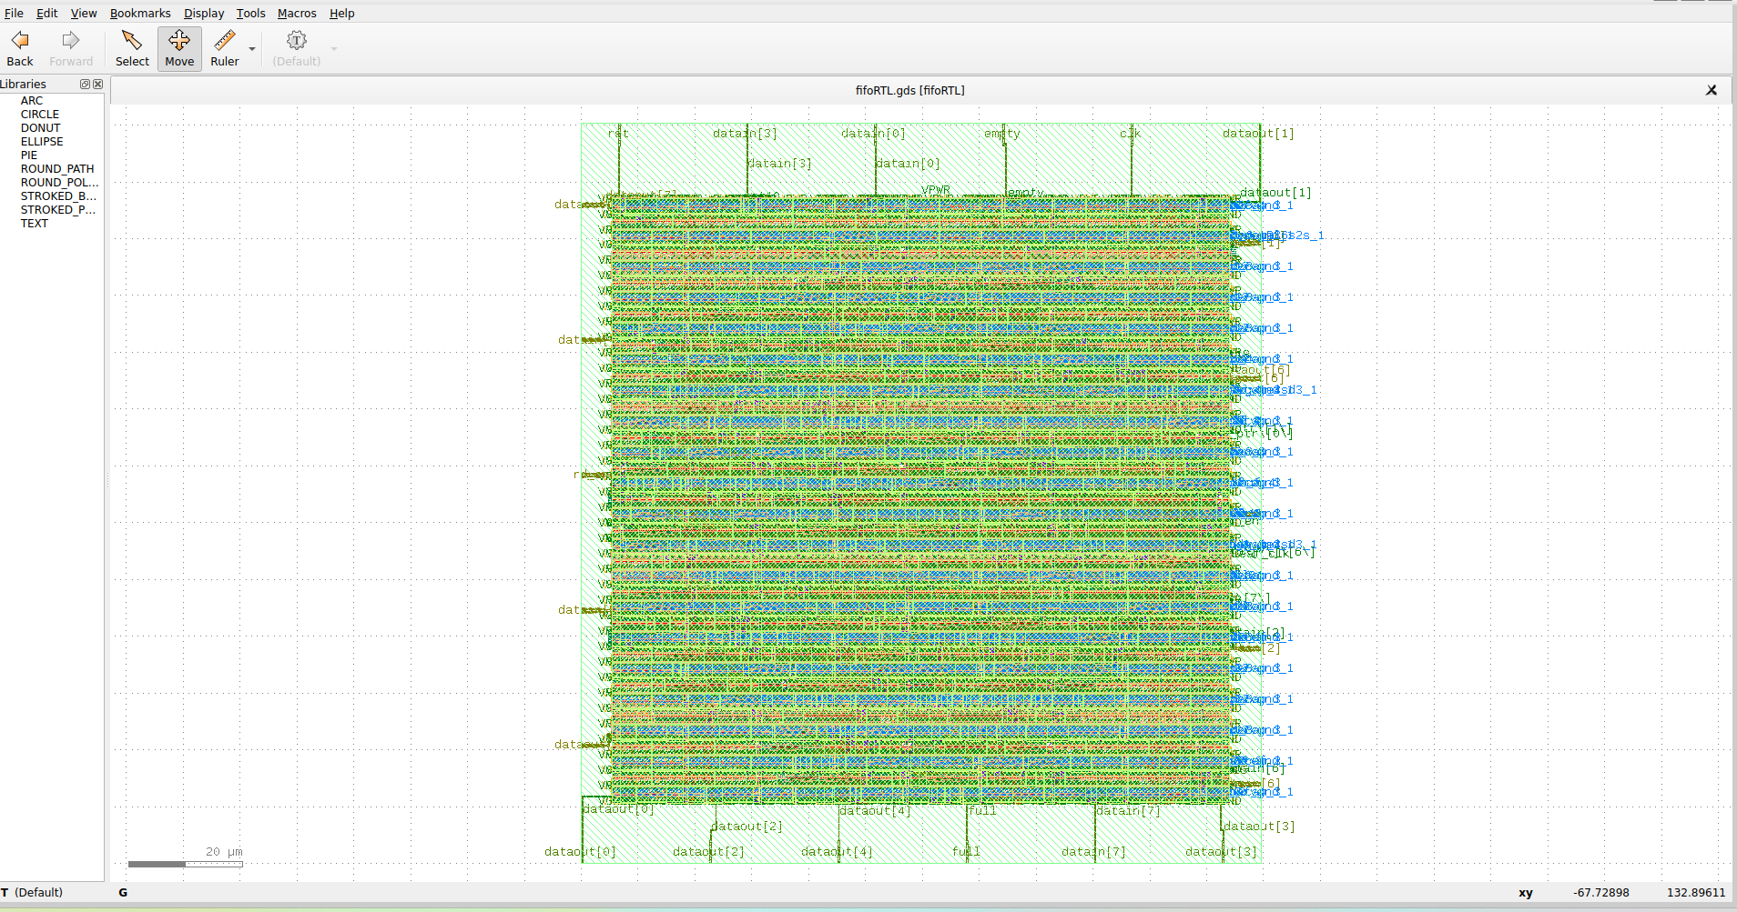
GDSII
prerna@LAPTOP-929QFRHD:~/OpenLane/designs/sync_fifo/runs/RUN_2026.04.22_08.11.11/results/final/gds$ klayout fifoRTL.gds
fifo design is fully ready for tapeout.
so physical layout actually goes to manufacturing

